Digital Design

CSCE 2114-L007

Blake Fasse

October 10, 2016

[bafasse@uark.edu](mailto:bafasse@uark.edu)

**Introduction**

**Design**

**Introduction**

The purpose of this lab is to understand how to create complex circuits using Quartus. The process was very simple and took no more than 30 minutes, however, because the Quartus software was having some complications the program could not be compiled and run on the FPGA board so the compilation was put off until the next week. The circuit was also turned into a vector waveform grade.

**Design**

The lab started by adding two inputs, one output and an add_sub input. A 2-to-1 MUX is also added and then the inputs and output are hooked up to the MUX. Once the circuit has been built the program is then compiled and then it will run on the FPGA board, or at least it would if Quartus wasn’t having any issues. After that a test bench used to measure input signals is built in Quartus.

**Results**

Since Quartus was having some issues the first time the last art of the lab was saved for the next week. There wasn’t much to the results to this lab other than to understand what was happening in the vector waveform graph. The waveform editing tool was used in Quartus to was used to bring values at certain bits up to 1, specifically the add-sub input and 4 of the dataa bits (there are a total on 8 bits, 0-7, on dataa) and then the simulation began. The vector waveform graph shows you the unsigned decimal values of the bits. Below is a picture of the results. 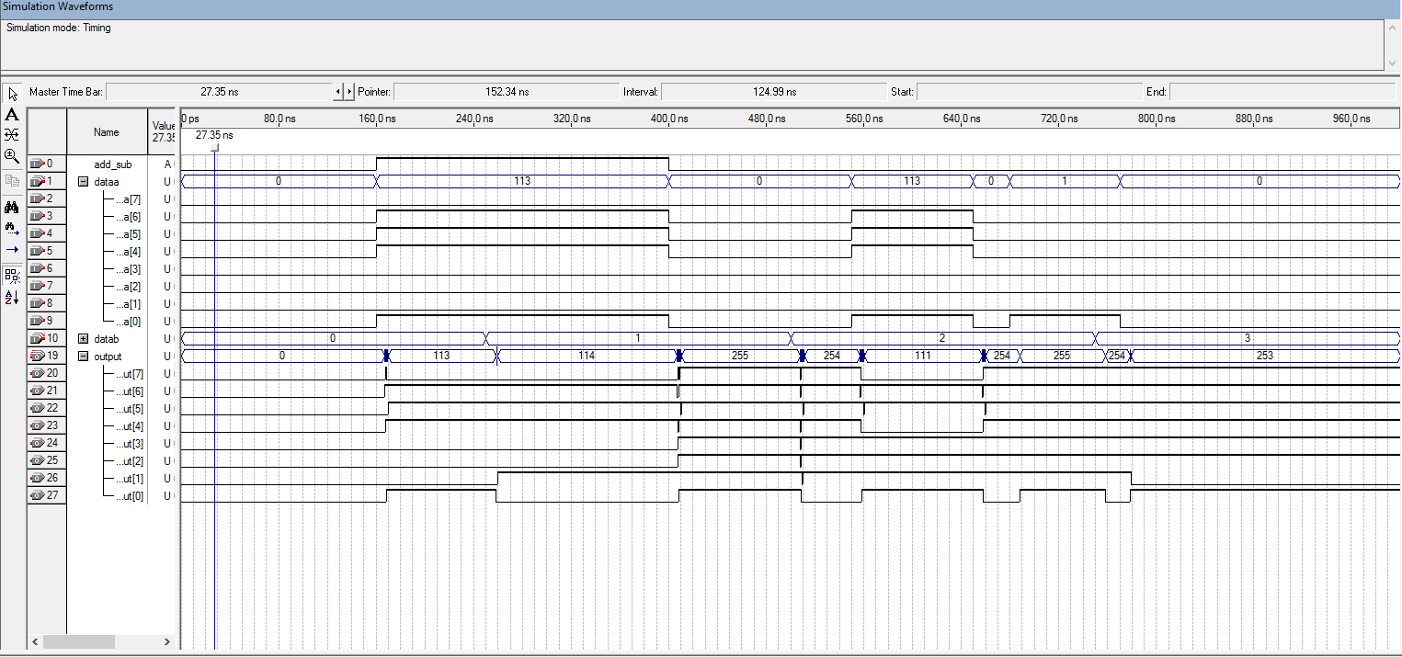

**Conclusion**

Technically this lab was split up into two parts just due to Quartus having some issues when this lab was assigned. By the time the second week came Quartus was back up and running so this lab was finished in 5 or 10 minutes before the start of next lab. Creating complex circuits using Quartus and how to implement in on the FPGA was the goal of this lab. This lab was not very difficult to complete but what the lab was trying to teach is still called into question.